

Lab Assignment #02
  - OOP
Instructor: Mr. Mohsin Ahmed

Student Name: |  | Muhammad Abdullah
Registration No: |  | FA24-BSE-042
Department: |  | Software Engineering
Submission Date: |  | 19th October 2022

  - COMSATS University Islamabad

package Lab_Assignment_2;

import java.math.BigDecimal;
import java.time.Instant;
import java.util.UUID;

// Interface for refunds
interface Refundable {
void refund(double amount);
}

// Composition
class AuditService {
public void record(String message) {
System.out.println("AUDIT: " + message);
}
}

// Base class
abstract class Payment {
// Encapsulation
private String payerId;
private double amount;

// Composition: has-a relationship with AuditService
protected AuditService auditService;

// Constructor
public Payment(String payerId, double amount, AuditService auditService) {
this.payerId = payerId;
this.amount = amount;
this.auditService = auditService;
}

// Getter methods
public String getPayerId() {
return payerId;
}

public double getAmount() {
return amount;
}

public double substractAmount(double money) {
return this.amount -= money;
}
// Common method
public void evaluateRisk() {
System.out.println("Performing risk evaluation for amount $" + this.amount);
}

// Abstract method
public abstract void processPayment();
}

// Credit Card Payment
class creditCardPayment extends Payment implements Refundable { // implements means agreeing to the contract of that
// interface
private String cardNumber;

public creditCardPayment(String payerId, double amount, String cardNumber, AuditService auditService) {
super(payerId, amount, auditService); // this super() calls the parent class
this.cardNumber = cardNumber;
}

@Override
public void processPayment() {
evaluateRisk();
auditService.record("Processing Credit Card payment for " + getPayerId());
System.out.println("Payment of $" + getAmount() + " made using Credit Card ending with "
+ cardNumber.substring(cardNumber.length() - 4));
}

@Override
public void refund(double amount) {
super.substractAmount(amount);
System.out.println("Refund of $" + amount + " issued to Credit Card ending with "
+ cardNumber.substring(cardNumber.length() - 4));
}

}

// Wallet Payment
class digitalWalletPayment extends Payment implements Refundable {
private String walletId; // encapsulated

public digitalWalletPayment(String payerId, double amount, String walletId, AuditService auditService) {
super(payerId, amount, auditService);
this.walletId = walletId;
}

@Override
public void processPayment() {
evaluateRisk();
auditService.record("Processing Digital Wallet payment for " + getPayerId());
System.out.println("Payment of $" + getAmount() + " completed using Wallet ID: " + walletId);
}

@Override
public void refund(double amount) {
super.substractAmount(amount);
System.out.println("Refund of $" + amount + " issued to Digital Wallet ending with "
+ walletId.substring(walletId.length() - 4));
}
}

// Crypto Payment
class cryptoCurrencyPayment extends Payment implements Refundable {
private String blockchainKey; // encapsulated

public cryptoCurrencyPayment(String payerId, double amount, String blockchainKey, AuditService auditService) {
super(payerId, amount, auditService);
this.blockchainKey = blockchainKey;
}

@Override
public void processPayment() {
evaluateRisk();
auditService.record("Processing Crypto payment for " + getPayerId());
System.out
.println("Crypto transaction of $" + getAmount() + " verified using blockchain key: " + blockchainKey);
}

@Override
public void refund(double amount) {
super.substractAmount(amount);
System.out.println("Refund of $" + amount + " issued to Crypto Wallet ending with "
+ blockchainKey.substring(blockchainKey.length() - 4));
}
}

public class runner {
public static void main(String[] args) {
// One AuditService shared by all ( Composition )
AuditService audit = new AuditService();

Payment card = new creditCardPayment("User123", 250.0, "1234567890123456", audit);
Payment wallet = new digitalWalletPayment("User456", 80.0, "WALLET-9988", audit);
Payment crypto = new cryptoCurrencyPayment("User789", 500.0, "11111111112222", audit);

card.processPayment();
wallet.processPayment();
crypto.processPayment();

// interface usage
if (card instanceof Refundable) {
((Refundable) card).refund(100.0);
}
if (wallet instanceof Refundable) {
((Refundable) wallet).refund(50.0);
}

System.out.println(card.getAmount()); // Should get 150
}
}

Output: 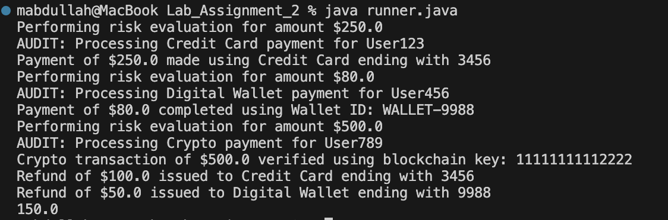

Explanation by concept
1. Inheritance & Method Overriding
- Payment is the base class.
- creditCardPayment, digitalWalletPayment, and cryptoCurrencyPayment inherit from it.
- Each subclass overrides processPayment() to define its own payment logic.
@Override
public void processPayment() {
// custom logic for each type
}
This shows how inheritance, while overriding gives each payment type unique behavior.

2. Encapsulation (Data Protection)
- Sensitive fields like cardNumber, walletId, and blockchainKey are private.
- They can’t be accessed directly from outside the class.
- Only controlled access through methods (getPayerId(), getAmount()) or used internally.
This secures private information (card numbers, wallet IDs, etc.).

3. Composition (Has-A relationship)
- Each Payment has an AuditService object.
- Instead of inheriting, it uses that service → reduces coupling.
protected AuditService auditService; // composition
Composition keeps auditing logic separate from payment logic; modular and reusable

4. Extending with Refunds
If in the future more payment types need refunds:
- Use an interface (Refundable), not inheritance.
- Reason: not all payment types will support refunds.
- Using an interface allows only those that need it to implement it.

This is more flexible and avoids forcing unnecessary refund behavior into every payment class.

